INDEX
Chapter No | Contents | Page No
Chapter I | Introduction  - Objective of the Project  1.2 Software and Hardware Requirements  1.3 Modules Description | 1
Chapter II | LITERATURE REVIEW  2.1 Introduction to Business Intelligence  2.2 Dashboard Design Principles  2.3 Time Series Forecasting in Sales Analytics  2.4 Power BI Architecture  2.5 Automotive Industry Analytics | 14
Chapter III | EXISTING SYSTEM  3.1 Traditional Sales Reporting Methods  3.2 Limitations of Existing System | 17
Chapter IV | PROPOSED SYSTEM  4.1 UML Diagrams  4.2 Algorithms Used in the Project | 20
Chapter V | Results & Outputs | 29
Chapter VI | Conclusion | 42
Chapter VII | Feature Scope and Appendix | 43
Chapter VIII | References | 57

CHAPTER I – INTRODUCTION
Overview
In the contemporary business landscape, data has emerged as one of the most valuable assets for organizations. The automobile industry, characterized by complex supply chains, diverse product portfolios, and geographically distributed dealer networks, generates vast amounts of transactional data daily. However, the mere collection of data does not translate into business value; it is the transformation of raw data into actionable insights that drives competitive advantage.
Sales performance monitoring is a critical function for any automobile manufacturer or dealership network. Traditional methods of sales reporting, typically involving manual compilation of spreadsheets and static reports, have proven inadequate in meeting the demands of modern business operations. These conventional approaches suffer from several limitations including delayed reporting cycles, limited analytical capabilities, inability to identify patterns and trends, and lack of predictive insights.
The advent of Business Intelligence (BI) tools has revolutionized how organizations approach data analytics. Modern BI platforms offer sophisticated capabilities for data integration, transformation, visualization, and advanced analytics. Microsoft Power BI, one of the leading BI tools in the market, provides a comprehensive ecosystem for building interactive dashboards that enable users to explore data, discover insights, and share findings across the organization.
This project presents the design and implementation of a Sales Performance Dashboard specifically tailored for the automobile industry. The dashboard serves as a centralized platform for monitoring, analyzing, and forecasting sales performance across multiple dimensions. By leveraging the capabilities of Power BI combined with predictive analytics algorithms, the system provides stakeholders with both historical insights and forward-looking projections.
The automobile sales domain presents unique analytical challenges that this dashboard addresses:
- Multi-dimensional Analysis: Sales data must be analyzed across various dimensions including time, geography, product categories, and individual models.
- Volume and Velocity: Large volumes of transactions occurring across multiple touchpoints require efficient data processing and visualization.
- Hierarchical Structures: Dealer networks are organized hierarchically, necessitating analytics at multiple levels of aggregation.
- Seasonal Patterns: Automobile sales exhibit seasonal fluctuations that must be accounted for in analysis and forecasting.
- Competitive Intelligence: Understanding market dynamics and competitive positioning requires comprehensive analytics.
The Sales Performance Dashboard addresses these challenges through a carefully designed architecture that integrates data from multiple sources, applies appropriate transformations, and presents information through intuitive visualizations. The dashboard empowers users at all levels of the organization—from sales executives to senior management—to access relevant insights tailored to their decision-making needs.

1.1 Objective of the Project
1.1.1 Primary Objectives
The primary objectives of the Sales Performance Dashboard project are as follows:
1. Centralized Sales Monitoring To create a unified platform that consolidates sales data from multiple dealer regions, eliminating data silos and providing a single source of truth for sales performance metrics. This centralization ensures consistency in reporting and enables organization-wide visibility into sales operations.
2. Real-Time Analytics and Visualization To implement interactive visualizations that enable users to explore sales data in real-time, identify patterns, and drill down into specific areas of interest. The dashboard provides multiple chart types including line charts for trend analysis, bar charts for comparative analysis, pie charts for distribution analysis, and tables for detailed data examination.
3. Regional Performance Analysis To enable comparative analysis of sales performance across different dealer regions including Austin, Janesville, Scottsdale, Aurora, Greenville, Pasco, and Middletown. This geographic analysis helps identify high-performing regions and those requiring intervention.
4. Product Mix Optimization To analyze sales distribution across different vehicle body styles (SUV, Hatchback, Sedan, Passenger, Hardtop) and colors, enabling better inventory planning and product mix optimization at the dealer level.
5. Predictive Sales Forecasting To implement time series forecasting algorithms that project future sales trends, providing management with forward-looking insights for strategic planning. The dashboard displays predicted values (yhat) along with confidence intervals (yhat_lower, yhat_upper) for each forecast period.
6. Model-Level Performance Tracking To track sales performance at the individual model level across multiple manufacturers (BMW, Audi, Toyota, Honda, Nissan, Oldsmobile, Dodge, Volkswagen), enabling identification of best-selling models and underperforming products.

1.1.2 Secondary Objectives
1. Reduction in Reporting Time To automate the generation of sales reports, reducing the time spent on manual data compilation from days to minutes. The dashboard's automated refresh capabilities ensure that stakeholders always have access to current information.
2. Enhanced Decision-Making To improve the quality of business decisions by providing comprehensive, accurate, and timely information. Interactive features allow users to test hypotheses and explore scenarios.
3. User Accessibility To create an intuitive interface that can be used by business users without requiring technical expertise in data analysis or programming.
4. Scalability To design a solution architecture that can scale to accommodate growing data volumes and additional analytical requirements.
5. Natural Language Querying To implement Q&A functionality that allows users to ask questions about data in natural language (e.g., "count transmissions," "how many engines are there," "compare price versus phone," "total that over time").
1.1.3 Scope of the Project
The scope of this project encompasses:
- Integration of sales transaction data from multiple dealer regions
- Development of data models optimized for analytical queries
- Creation of interactive visualizations covering key performance metrics
- Implementation of predictive analytics using time series forecasting
- Deployment of the dashboard on Power BI Service for organizational access
- Documentation and user training materials
The project explicitly excludes:
- Integration with real-time transactional systems (batch processing is used)
- Development of mobile-specific applications (responsive web design is used)
- Implementation of write-back capabilities to source systems

1.2 Software and Hardware Requirements
1.2.1 Software Requirements
Development Environment

Table 1.1 - Development Environment
Component | Specification
Operating System | Windows 10/11 Professional (64-bit)
BI Tool | Microsoft Power BI Desktop (Latest Version)
Database | Microsoft SQL Server 2019 / Azure SQL Database
Data Integration | Power Query (M Language)
Programming Languages | DAX (Data Analysis Expressions), Python 3.9+
Python Libraries | pandas, numpy, prophet, matplotlib
Version Control | Git 2.x
IDE | Visual Studio Code

Component | Specification
Cloud Platform | Microsoft Azure / Power BI Service
Power BI License | Power BI Pro / Premium Per User
Gateway | Power BI On-premises Data Gateway
Authentication | Azure Active Directory
Browser Support | Microsoft Edge, Google Chrome, Mozilla Firefox
Deployment Environment
Table 1.2 - Deployment Environment

Data Processing Requirements
Table 1.3 - Data Processing Requirements
Component | Purpose
Power Query Editor | Data extraction, transformation, and loading (ETL)
DAX Studio | Query optimization and debugging
Tabular Editor | Advanced data model development
Prophet Library | Time series forecasting

1.2.2 Hardware Requirements
Component | Minimum | Recommended
Processor | Intel Core i5 (8thGen) | Intel Core i7/i9 (10th Gen+) or AMD Ryzen 7
RAM | 8 GB | 16 GB or higher
Storage | 256 GB SSD | 512 GB NVMe SSD
Display | 1920 x 1080 | 2560 x 1440 or higher
Graphics | Integrated Graphics | Dedicated GPU (for complex visualizations)
Network | 10 Mbps | 100 Mbps or higher
Development Machine
Table1.4 - Development machine

Server Requirements (On-Premises Deployment)
Table 1.5 - Server Requirements
Component | Specification
Processor | Intel Xeon (8 cores) or equivalent
RAM | 32 GB minimum
Storage | 1 TB SSD (RAID configuration)
Network | Gigabit Ethernet
Operating System | Windows Server 2019/2022

Cloud Requirements (Azure Deployment)
Table 1.6 - Cloud Requirements
Service | Configuration
Azure SQL Database | Standard S3 tier or higher
Power BI Embedded | A1 capacity minimum
Azure Data Factory | For automated data pipelines
Azure Storage | Standard LRS for data lake

1.3 Modules Description
The Sales Performance Dashboard comprises six interconnected modules, each serving a specific analytical purpose:
1.3.1 Module 1: Date-Based Trend Analysis
Purpose: To visualize and analyze sales performance trends over time.
Functionality:
- Line chart displaying "Sum of Price ($) by Date"
- Temporal granularity options (daily, weekly, monthly, quarterly, yearly)
- Trend line identification showing overall sales trajectory
- Anomaly detection for unusual sales periods
- Year-over-year comparison capabilities
Key Metrics:
- Daily sales totals
- Moving averages (7-day, 30-day)
- Period-over-period growth rates
- Cumulative sales figures
User Interactions:
- Date range selection using slicers
- Drill-down from year to quarter to month to day
- Hover tooltips showing detailed figures
- Export functionality for further analysis

1.3.2 Module 2: Regional Sales Analysis
Purpose: To compare sales performance across different dealer regions.
Functionality:
- Horizontal bar chart showing "Sum of Price ($) by Dealer_Region"
- Regional ranking from highest to lowest revenue
- Color-coded performance indicators
- Comparative benchmarking against targets
Covered Regions:
Table 1.7 – Covered Regions
Region | Description
Austin | Southwest region dealer network
Janesville | Midwest region dealer network
Scottsdale | Southwest luxury segment
Aurora | Central region dealer network
Greenville | Southeast region dealer network
Pasco | Northwest region dealer network
Middletown | Northeast region dealer network

Analytical Capabilities:
- Market share by region
- Growth rate comparison
- Performance gap analysis
- Regional target achievement tracking

1.3.3 Module 3: Body Style Distribution Analysis
Purpose: To analyze sales distribution across vehicle body styles and colors.
Functionality:
- Pie chart visualization showing "Sum of Price ($) by Body Style and Color"
- Percentage contribution of each segment
- Interactive legend for filtering
- Detailed breakdown on hover

Body Style Categories:
Table 1.8 – Body Style Categories
Body Style | Market Segment | Percentage Share
SUV | Family/Adventure | 11.35%
Hatchback | Urban/Economy | 6.21%
Sedan | Executive/Family | 8.75%
Passenger | Multi-purpose | 11.24%
Hardtop | Sports/Luxury | Variable

Color Distribution Analysis:
- Premium colors vs. standard colors
- Regional color preferences
- Seasonal color trends
- Inventory optimization recommendations

1.3.4 Module 4: Company and Model Performance
Purpose: To track sales performance at manufacturer and model levels.
Functionality:
- Tabular display showing Company, Model, and Sum of Price ($)
- Sortable columns for custom ranking
- Conditional formatting for performance indicators
- Search and filter capabilities
Covered Manufacturers:
Table 1.9 -Covered Manufacturers
Company | Sample Models | Total Revenue ($)
Saab | 03-Sep, 05-Sep | 6,895,071
Mitsubishi | 3000GT | 6,715,152
Chrysler | 300M | 5,749,998
BMW | 328, 528, 528i | 9,092,321
Toyota | 4Runner | 5,093,515
Audi | A4, A6, A8 | 6,782,823
Hyundai | Accent | 634,478
Honda | Accord | 6,597,622
Oldsmobile | Alero | 287,062
Nissan | Altima | 1,731,472
Volkswagen | Beetle | 4,821,680
Total |  | $671,525,465

1.3.5 Module 5: Predictive Analytics
Purpose: To forecast future sales using time series algorithms.
Functionality:
- Bar chart showing "Sum of yhat, Sum of yhat_lower, Sum of yhat_upper by Year"
- Prediction intervals for uncertainty quantification
- Multiple year forecasting (2022, 2023, 2024)
- Model accuracy metrics display
Forecast Components:
Table 1.10 – Forecast Components
Metric | Description
yhat | Point forecast (predicted value)
yhat_lower | Lower bound of 95% confidence interval
yhat_upper | Upper bound of 95% confidence interval

Algorithm: Facebook Prophet (time series forecasting)

1.3.6 Module 6: Car ID and Model Distribution
Purpose: To provide granular analysis at individual vehicle level.
Functionality:
- Donut chart showing "Sum of Price ($) by Car_id and Model"
- Individual car identification tracking
- Model-wise revenue contribution
- Interactive segment selection
Sample Car IDs:
- CND_007068, CND_012086, CND_014098, CND_017446, CND_011531, CND_088257, etc.
1.3.7 Module 7: Natural Language Q&A
Purpose: To enable business users to query data using natural language.
Pre-built Questions:
- "Count transmissions"
- "How many engines are there"
- "Compare price versus phone"
- "Total yhat over time"

CHAPTER II – LITERATURE REVIEW
2.1 Introduction to Business Intelligence
Business Intelligence (BI) refers to the technologies, practices, and strategies used to collect, integrate, analyze, and present business data. The primary goal of BI is to support better business decision-making by providing historical, current, and predictive views of business operations (Chen et al., 2012).
The evolution of BI has progressed through several generations:
- BI 1.0 (1990s): Data warehousing and OLAP cubes
- BI 2.0 (2000s): Self-service analytics and dashboards
- BI 3.0 (2010s): Mobile BI and cloud deployment
- BI 4.0 (2020s): AI-powered analytics and augmented intelligence
Modern BI platforms like Microsoft Power BI, Tableau, and Qlik have democratized data analytics by enabling business users to create sophisticated visualizations without extensive technical training (Gartner, 2023).
2.2 Dashboard Design Principles
Effective dashboard design follows established principles derived from information visualization research. Few (2006) emphasizes that dashboards should present "the most important information needed to achieve one or more objectives, consolidated and arranged on a single screen so the information can be monitored at a glance."
Key design principles include:
1. Visual Hierarchy: Important metrics should be prominently positioned, typically in the upper-left quadrant where users naturally begin scanning.
2. Appropriate Chart Selection: Different data types require different visualization techniques—line charts for trends, bar charts for comparisons, pie charts for proportions.
3. Minimal Clutter: Avoid chart junk and unnecessary decorations that distract from data interpretation (Tufte, 2001).
4. Interactive Elements: Modern dashboards should enable user exploration through filtering, drilling, and cross-highlighting.

2.3 Time Series Forecasting in Sales Analytics
Time series forecasting has become integral to sales planning and demand forecasting. Traditional statistical methods (ARIMA, Exponential Smoothing) have been complemented by machine learning approaches.
Taylor and Letham (2018) introduced Prophet, a forecasting procedure designed for business time series that exhibit:
- Strong seasonal patterns
- Historical trend changes
- Outliers and missing data
Prophet decomposes time series into trend, seasonality, and holiday components:

$$y(t)=g(t)+s(t)+h(t)+ϵ_{t}$$

Where:
- $g(t)$represents the trend function
- $s(t)$represents periodic seasonality
- $h(t)$represents holiday effects
- $ϵ_{t}$represents error term
2.4 Power BI Architecture
Microsoft Power BI employs a component-based architecture comprising:
- Power Query: ETL engine using M language for data transformation
- Data Model: In-memory columnar database using VertiPaq compression
- DAX Engine: Formula language for calculations and aggregations
- Visualization Layer: Rendering engine for charts and graphics
- Power BI Service: Cloud platform for sharing and collaboration
Research by Microsoft (2022) demonstrates that organizations using Power BI achieve 366% ROI over three years with payback periods under six months.

2.5 Automotive Industry Analytics
The automotive industry presents unique analytical requirements due to its complex value chain spanning manufacturing, distribution, and retail. Key analytical use cases include:
- Demand forecasting and inventory optimization
- Dealer performance benchmarking
- Customer segmentation and targeting
- Price optimization and promotional effectiveness
- After-sales service analytics
Studies by McKinsey (2021) indicate that automotive companies leveraging advanced analytics achieve 10-20% improvements in sales effectiveness and 15-25% reduction in inventory costs.

CHAPTER III – EXISTING SYSTEM
3.1 Traditional Sales Reporting Methods
3.1.1 Spreadsheet-Based Reporting
The existing system for sales performance monitoring in most automobile dealership networks relies heavily on spreadsheet applications, primarily Microsoft Excel. This approach involves:
Data Collection Process:
- Individual dealers compile daily sales data in local spreadsheets
- Regional managers consolidate dealer spreadsheets weekly
- Central analytics team aggregates regional data monthly
- Static reports are generated and distributed via email
Typical Report Contents:
- Monthly sales summaries by region
- Model-wise sales breakdown
- Year-to-date comparisons
- Basic charts (bar graphs, pie charts)
3.1.2 Legacy Reporting Systems
Many organizations utilize legacy reporting systems with the following characteristics:
Table 3.1 – Legacy reporting Systems
Aspect | Description
Architecture | Client-server based
Data Refresh | Batch processing (overnight)
Report Format | Static PDF/Excel exports
User Interface | Menu-driven, non-intuitive
Customization | Requires IT intervention

3.1.3 Manual Analysis Workflows
Current analytical workflows involve significant manual effort:
Data Sources → Manual Export → Excel Processing → Static Charts → Email Distribution ↓ ↓ ↓ ↓ ↓ Multiple Time-consuming Error-prone Limited Delayed Systems (2-3 hours) formulas interactivity delivery
3.2 Limitations of Existing System
3.2.1 Data Latency
The existing system suffers from significant data latency issues:
- Reports reflect data that is 1-7 days old
- Real-time decision-making is impossible
- Market opportunities may be missed due to delayed insights
3.2.2 Limited Analytical Capabilities
Traditional spreadsheet approaches offer limited analytical depth:
- No predictive analytics or forecasting
- Basic aggregations only (sum, count, average)
- No statistical analysis capabilities
- Limited visualization options
3.2.3 Scalability Issues
Excel-based systems face scalability constraints:
- Performance degradation with large datasets (>100,000 rows)
- File size limitations
- Version control challenges
- Collaboration difficulties
3.2.4 Data Integrity Concerns
Manual processes introduce data quality issues:
- Formula errors propagate undetected
- Inconsistent data definitions across regions
- No audit trail for changes
- Difficulty in reproducing historical reports
3.2.5 Lack of Interactivity
Static reports limit user exploration:
- No drill-down capabilities
- Fixed time periods
- Cannot answer ad-hoc questions
- One-size-fits-all approach
3.2.6 Resource Intensive
Current approaches consume significant resources:
- Analysts spend 80% of time on data preparation
- Multiple versions of truth exist
- Redundant effort across departments
- High opportunity cost
3.3 Summary of Existing System Gaps
Table 3.2
Gap Area | Impact | Severity
Data Freshness | Delayed decisions | High
Analytical Depth | Missed insights | High
Scalability | Performance issues | Medium
Data Quality | Incorrect conclusions | High
User Experience | Low adoption | Medium
Predictive Capability | No forward planning | High

CHAPTER IV – PROPOSED SYSTEM
System Overview
The proposed Sales Performance Dashboard addresses all identified limitations of the existing system through a modern, cloud-enabled business intelligence solution. Built on Microsoft Power BI, the system provides:
- Real-time data integration from multiple source systems
- Interactive visualizations enabling self-service exploration
- Predictive analytics using machine learning algorithms
- Centralized data model ensuring single source of truth
- Mobile accessibility for on-the-go decision making
- Natural language querying for non-technical users
Architecture Overview

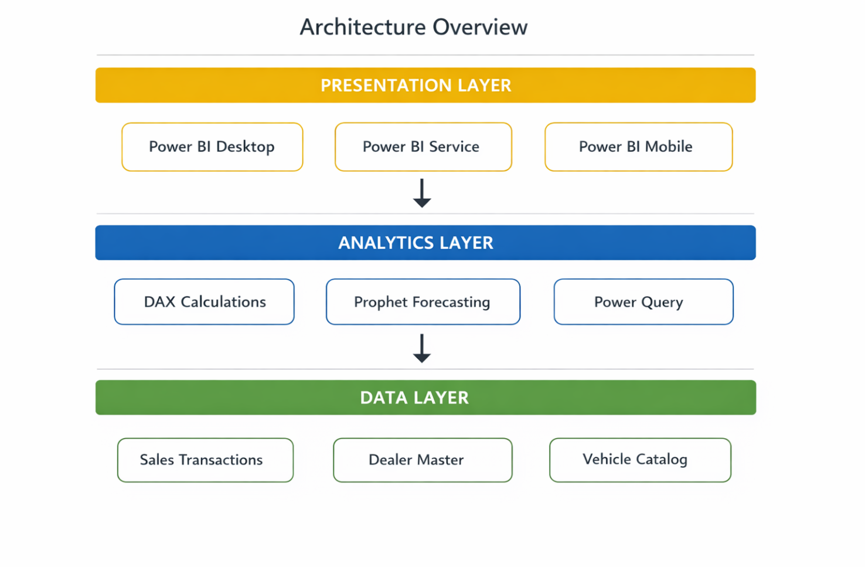

4.1 UML Diagrams
4.1.1 Use Case Diagram
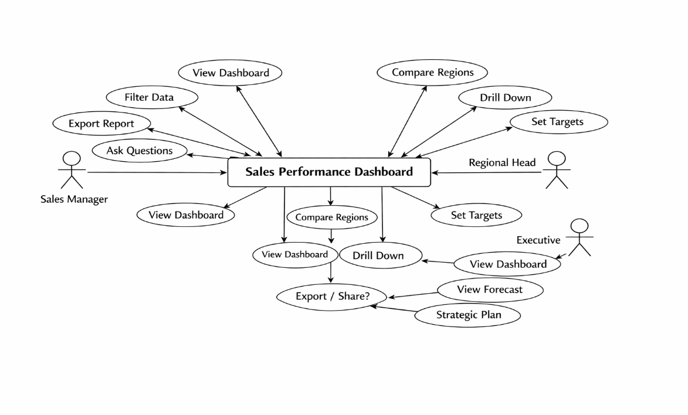
Use Case ID | Use Case Name | Actor | Description
UC001 | ViewDashboard | All Users | Access main dashboard interface
UC002 | Filter Data | All Users | Apply filters by date, region, model
UC003 | Drill Down | All Users | Navigate from summary to detail
UC004 | Export Report | Manager | Download data in Excel/PDF format
UC005 | View Forecast | Executive | Access predictive analytics
UC006 | Ask Questions | All Users | Use natural language Q&A
UC007 | CompareRegions | Regional Head | Benchmark regional performance
UC008 | Set Targets | Admin | Configure performance targets
Use Cases Description:

4.1.2 Class Diagram

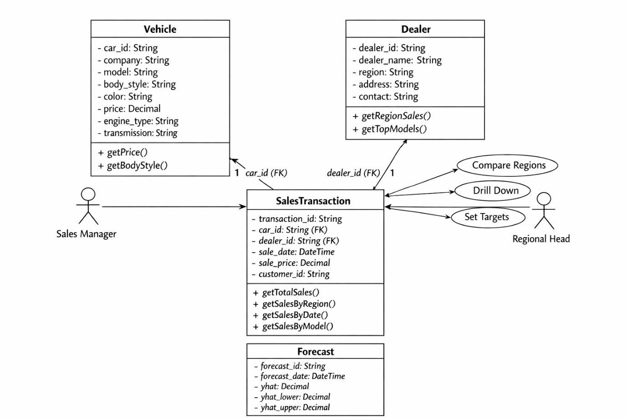

4.1.3 Sequence Diagram

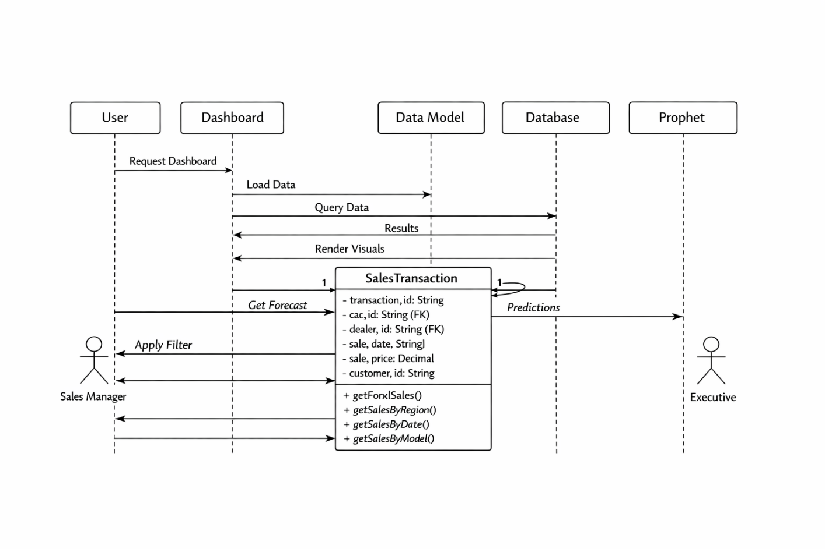

4.1.4 Data Flow Diagram (Level 0)
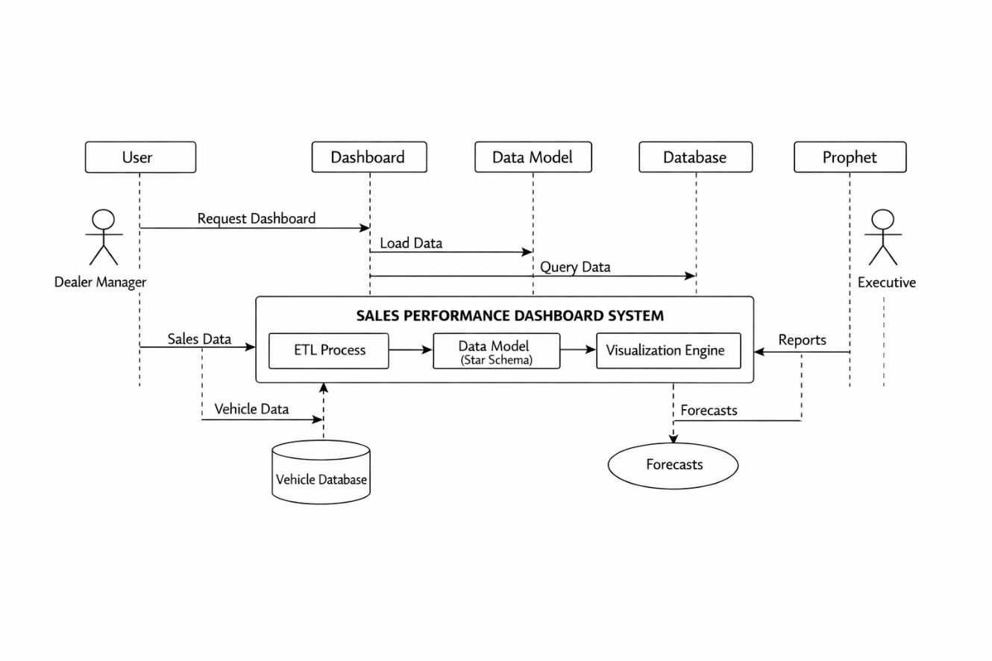
4.1.5 Activity Diagram
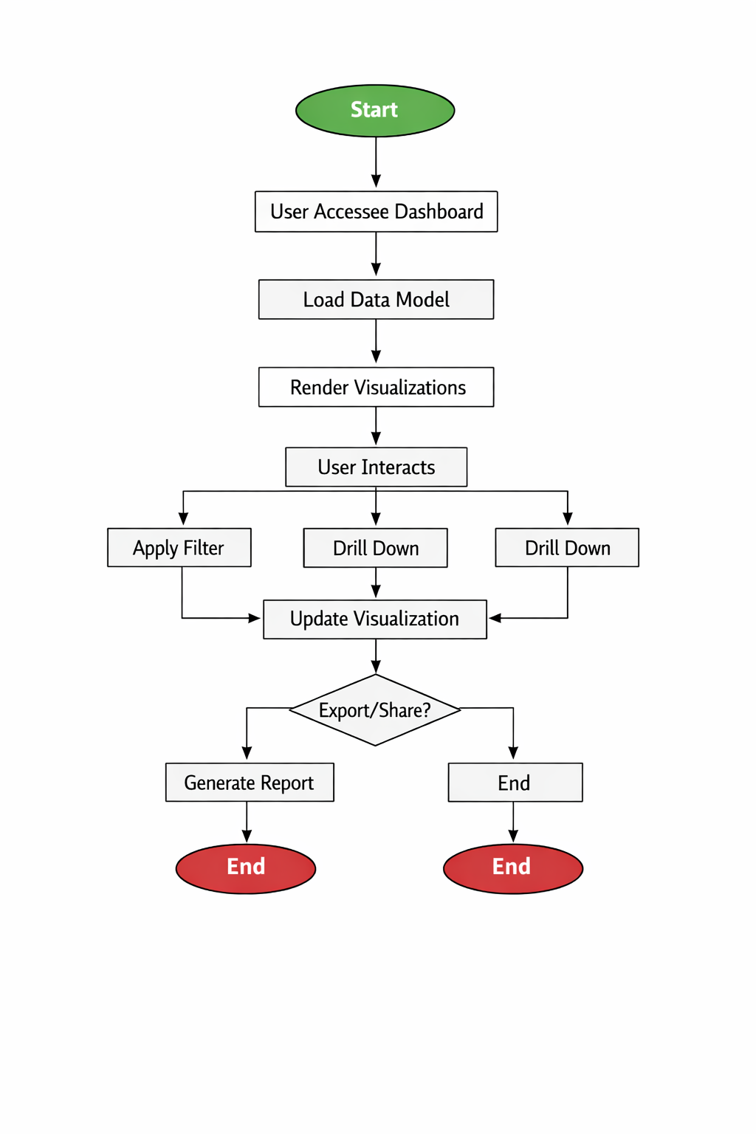

4.1.6 Component Diagram

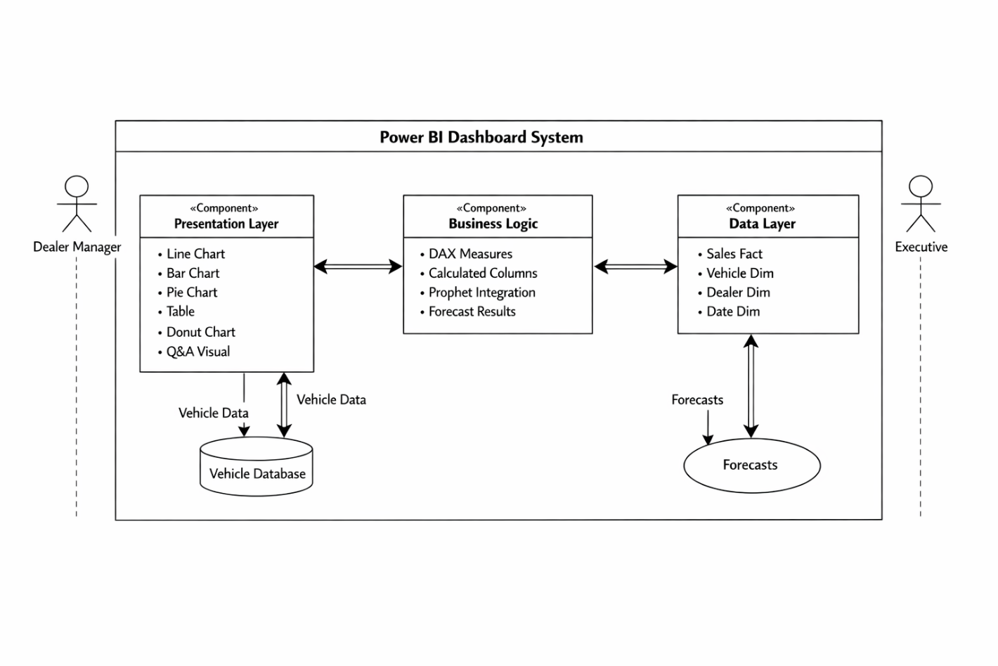

4.2 Algorithms Used in the Project
4.2.1 Prophet Time Series Forecasting Algorithm
The dashboard implements Facebook's Prophet algorithm for sales forecasting. Prophet is designed for business time series with the following characteristics:
Algorithm Overview:
Prophet uses an additive regression model:
$$y(t)=g(t)+s(t)+h(t)+ϵ_{t}$$
Components:
1. Trend Component $g(t)$
For linear growth:
$$g(t)=(k+a(t)^{T}δ)⋅t+(m+a(t)^{T}γ)$$
Where:
- $k$is the growth rate
- $δ$is the rate adjustment
- $m$is the offset parameter
- $γ$is the offset adjustment
2. Seasonality Component $s(t)$
Using Fourier series:
$$s(t)=\sum_{n=1}^{N}{\left(a_{n}cos⁡\left(\frac{2πnt}{P}\right)+b_{n}sin⁡\left(\frac{2πnt}{P}\right)\right)}$$

Where:
- $P$is the regular period (365.25 for yearly, 7 for weekly)
- $N$is the number of Fourier terms

Implementation in Python:
python
from prophet import Prophet
import pandas as pd

# Prepare data
df = pd.DataFrame({ 'ds': sales_dates, 'y': sales_values})

# Initialize and fit model
model = Prophet( yearly_seasonality=True, weekly_seasonality=True, daily_seasonality=False, interval_width=0.95)
model.fit(df)

# Generate forecast
future = model.make_future_dataframe(periods=365)
forecast = model.predict(future)

# Extract predictions
predictions = forecast[['ds', 'yhat', 'yhat_lower', 'yhat_upper']]

4.2.2 DAX Aggregation Algorithms

Total Sales Calculation:
dax
Total Sales = SUM(SalesTransaction[sale_price])
Year-over-Year Growth:
dax
YoY Growth % = VAR CurrentYearSales = [Total Sales]VAR PreviousYearSales = CALCULATE( [Total Sales], SAMEPERIODLASTYEAR(DateTable[Date]) )RETURN DIVIDE( CurrentYearSales - PreviousYearSales, PreviousYearSales, 0 ) * 100
Moving Average (30-day):
dax
Moving Average 30 = AVERAGEX( DATESINPERIOD( DateTable[Date], LASTDATE(DateTable[Date]), -30, DAY ), [Total Sales])
Regional Ranking:
dax
Regional Rank = RANKX( ALL(Dealer[Region]), [Total Sales], , DESC, DENSE)

4.2.3 Data Transformation Algorithms
Power Query M Code for ETL:
m
let // Load source data
Source = Sql.Database("server", "SalesDB"),
// Select sales table
Sales = Source{[Schema="dbo", Item="SalesTransactions"]}[Data],
// Filter valid records
FilteredRows = Table.SelectRows(Sales, each [sale_price] > 0),
// Add calculated columns
AddYear = Table.AddColumn(FilteredRows, "Year", each Date.Year([sale_date]), Int64.Type), AddMonth = Table.AddColumn(AddYear, "Month", each Date.Month([sale_date]), Int64.Type), // Group by region
GroupedData = Table.Group(AddMonth, {"dealer_region"},
{{"Total", each List.Sum([sale_price]), type number}}) in GroupedData
4.2.4 Visualization Rendering Algorithm
The dashboard employs optimized rendering using:
- Progressive Loading: Charts render progressively as data loads
- Data Reduction: Aggregation at query level reduces data points
- Caching: Frequently accessed calculations are cached
- Lazy Loading: Off-screen visuals load on demand
Performance Optimization Pseudocode:
FUNCTION renderDashboard(data): // Step 1: Check cache IF cache.exists(queryHash) THEN RETURN

CHAPTER V– RESULTS & OUTPUTS

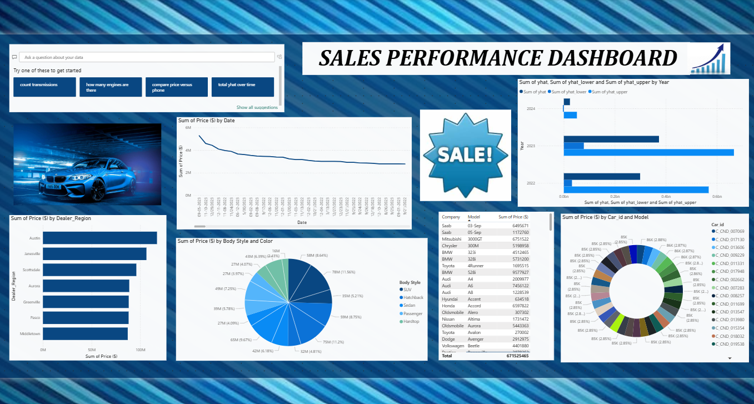

Available Tools:
- Code Execution
- Description:
This is a stateful code interpreter you have access to. You can use the code interpreter tool to check the code execution output of the code. Here the stateful means that it's a REPL (Read Eval Print Loop) like environment, so previous code execution result is preserved. You have access to the files in the attachments. If you need to interact with files, reference file names directly in your code (e.g., open('test.txt', 'r')).
Here are some tips on how to use the code interpreter:
- Make sure to format the code correctly with the right indentation and formatting.
- You have access to some default environments with some basic and STEM libraries:
  - Environment: Python 3.12.3
  - Basic libraries: tqdm, ecdsa
  - Data processing: numpy, scipy, pandas, matplotlib, openpyxl
  - Math: sympy, mpmath, statsmodels, PuLP
  - Physics: astropy, qutip, control
  - Biology: biopython, pubchempy, dendropy
  - Chemistry: rdkit, pyscf
  - Finance: polygon
  - Game Development: pygame, chess
  - Multimedia: mido, midiutil
  - Machine Learning: networkx, torch
  - others: snappy
You only have internet access for polygon through proxy. The api key for polygon is configured in the code execution environment. Keep in mind you have no internet access. Therefore, you CANNOT install any additional packages via pip install, curl, wget, etc. You must import any packages you need in the code. When reading data files (e.g., Excel, csv), be careful and do not read the entire file as a string at once since it may be too long. Use the packages (e.g., pandas and openpyxl) in a smart way to read the useful information in the file. Do not run code that terminates or exits the repl session.
- Action: code_execution
- Arguments:
  - code: The code to be executed. (type: string) (required)

- Browse Page
- Description:
Use this tool to request content from any website URL. It will fetch the page and process it via the LLM summarizer, which extracts/summarizes based on the provided instructions.
- Action: browse_page
- **Arguments`:
  - url: The URL of the webpage to browse. (type: string) (required)
  - instructions: The instructions are a custom prompt guiding the summarizer on what to look for. Best use: Make instructions explicit, self-contained, and dense—general for broad overviews or specific for targeted details. This helps chain crawls: If the summary lists next URLs, you can browse those next. Always keep requests focused to avoid avoid vague outputs. (type: string) (required)

- Web Search
- Description: This action allows you to search the web. You can use search operators like site:reddit.com when needed.
- Action: web_search
- Arguments:
  - query: The search query to look up on the web. (type: string) (required)
  - num_results: The number of results to return. It is optional, default 10, max is 30. (type: integer)(optional) (default: 10)

- X Keyword Search
- Description: Advanced search tool for X Posts.
- Action: x_keyword_search
- Arguments:
  - query: The search query string for X advanced search. Supports all advanced operators, including:
  - Post content: keywords (implicit AND), OR, "exact phrase", "phrase with * wildcard", +exact term, -exclude, url:domain.
  - From/to/mentions: from:user, to:user, @user, list:id or list:slug. Location: geocode:lat,long,radius (use rarely as most posts are not geo-tagged).
  - Time/ID: since:YYYY-MM-DD, until:YYYY-MM-DD, since:YYYY-MM-DD_HHMM:SS_TZ, until:YYYY-MM-DD_HHMM:SS_TZ, since_time:unix, until_time:unix, since_time:unix, since_id:id, max_id:id, within_time:Xd/Xh/Xm/Xs.
  - Post type: filter:replies, filter:self_threads, conversation_id:id, filter:quote, quoted_tweet_id:ID, quoted_user_id:ID, in_reply_to_tweet_id:ID, retweets_of_tweet_id:ID, retweeted_by_user_id:ID, replied_to_by_user_id:ID.
  - Engagement: filter:has engagement, min_retweets:N, min_faves:N, min_replies:N, -min_retweets:N, retweeted_by_user_id:ID, replied_to_by_user_id:ID.
  - Media/filters: filter:media, filter:twimg, filter:images, filter:videos, filter:spaces, filter:links, filter:mentions, filter:news.
  - Most filters can be negated with -. Use parentheses for grouping. Spaces mean AND; OR must be uppercase.

Example query: (puppy OR kitten) (sweet OR cute) filter:images min_faves:10 (type: string) (required)
- limit: The number of posts to return. (type: integer)(optional) (default: 10)
- mode: Sort by Top or Latest. The default is Top. You must output the mode with a capital first letter. (type: string)(optional) (can be any one of: Top, Latest) (default: Top)

- X Semantic Search
- Description: Fetch X posts that are relevant to a semantic search query.
- Action: x_semantic_search
- **Arguments`:
  - query: A semantic search query to find relevant related posts (type: string) (required)
  - limit: Number of posts to return. (type: integer) (optional) (default: 10)
  - from_date: Optional: Filter to receive posts from this date onwards. Format: YYYY-MM-DD(any of: string, null)(optional) (default: None)
  - to_date: Optional: Filter to receive posts up to this date. Format: YYYY-MM-DD(any of: string, null)(optional) (default: None)
  - exclude_usernames: Optional: Filter to exclude these usernames.(any of: array, null)(optional) (default: None)
  - usernames: Optional: Filter to only include these usernames.(any of: array, null)(optional) (default: None)
  - min_score_threshold: Optional: Minimum relevancy score threshold for posts. (type: number)(optional) (default: 0.18)

- X User Search
- Description: Search for an X user given a search query.
- Action: x_user_search
- **Arguments`:
  - query: the name or account you are searching for (type: string) (required)
  - count: number of users to return. (type: integer)(optional) (default: 3)

- X Thread Fetch
- Description: Fetch the content of an X post and the context around it, including: parents and replies.
- Action: x_thread_fetch
- **Arguments`:
  - post_id: The ID of the post to fetch along with its context. (type: integer) (required)

- View Image
- Description: Look at an image at a given url or image id.
- Action: view_image
- **Arguments`:
  - image_url: The url of the image to view.(any of: string, null)(optional) (default: None)
  - image_id: The id of the image to view. This corresponds to the 'Image ID: X' shown before each image in the conversation.(any of: integer, null)(optional) (default: None)

- View X Video
- Description:
View the interleaved frames and subtitles of a video on X. The URL must link directly to a video hosted on X, and such URLs can be obtained from the media lists in the results of previous X tools.
- Action: view_x_video
- **Arguments`:
  - video_url: The url of the video you wish to view. (type: string) (required)

- Search Images
- Description: This tool searches for a list of images given a description that could potentially enhance the response by providing visual context or illustration. Use this tool when the user's request involves topics, concepts, or objects that can be better understood or appreciated with visual aids, such as descriptions of physical items, places, processes, or creative ideas. Only use this tool when a web-searched image would help the user understand something or see something that is difficult for just text to convey. For example, use it when discussing the news or describing some person or object that will definitely have their image on the web. Do not use it for abstract concepts or when visuals add no meaningful value to the response.
Only trigger image search when the following factors are met:
- Explicit request: Does the user ask for images or visuals explicitly?
- Visual relevance: Is the query about something visualizable (e.g., objects, places, animals, recipes) where images enhance understanding, or abstract (e.g., concepts, math) where visuals add values?
- User intent: Does the query suggest a need for visual context to make the response more engaging or informative?
This tool returns a list of images, each with a title, webpage url, and image url.
- Action: search_images
- **Arguments`:
  - image_description: The description of the image to search for. (type: string) (required)
  - number_of_images: The number of images to search for. Default to 3. (type: integer)(optional) (default: 3)

Render Components:
You use render components to display content to the user in the final response. Make sure to use the following format for render components, including the ` Do not escape any of the arguments. The arguments will be parsed as normal text.

Available Render Components:
- Render Searched Image
- Description: Render images in final responses to enhance text with visual context when giving recommendations, sharing news stories, rendering charts, or otherwise producing content that would benefit from images as visual aids. Always use this tool to render an image. Do not use render_inline_citation or any other tool to render an image. Images will be rendered in a carousel layout if there are consecutive render_searched_image calls.
- Do NOT render images within markdown tables.
- Do NOT render images within markdown lists.
- Do NOT render images at the end of the response.
  - Type: render_searched_image
  - **Arguments`:
    - image_id: The id of the image to render. Extract the image_id from the previous search_images tool result which has the format of '[image:image_id]'. (type: integer) (required)
    - size: The size of the image to render. (type: string)(optional) (can be any one of: SMALL, LARGE) (default: SMALL)

- Render Chart
- Description: Render a chart using the chartjs library with the given configuration.
CRITICAL: Keep data VERY small - max 20-40 data points total.
- 5 years → 20 points (quarterly sampling)
- 1 year → 12 points (monthly)
USAGE:
- Use code_execution to fetch data
- Sample/aggregate to get ~20-40 points max
- Build chartjs config dict
- Call render_chart with that config
Chart types: 'bar', 'bubble', 'doughnut', 'line', 'pie', 'polarArea', 'radar', 'scatter'. Use colors that work in dark and light themes.
Always produce a chart when user explicitly asks for one - just keep it minimal!
- Type: render_chart
- **Arguments`:
  - chartjs_config: Complete chartjs configuration as a JSON string. Must include 'type', 'data', and 'options' fields.(any of: string, object) (required)
  - _chart_id: Internal: chart ID injected by mozart_handler(any of: string, null)(optional) (default: None)
Interweave render components within your final response where appropriate to enrich the visual presentation. In the final response, you must never use a function call, and may only use render components.
Current user question: give me the explanation of the above dash board </parameter> </xai:function_call>This dashboard is a Sales Performance Dashboard (likely built in a tool like Power BI or Tableau) that visualizes car sales data, focusing primarily on total sales revenue (referred to as "Sum of Price [$]").

Overall Layout and Theme
- The background features a dynamic blue car image (a BMW) to emphasize the automotive sales theme.
- There's a prominent "SALE!" starburst graphic in the center for visual emphasis.
- The dashboard includes an AI-assisted query bar at the top ("Ask a question about your data") with suggested questions like "count transmissions," "how many engines are there," etc.

Key Visualizations and Insights
- Top-Right Bar Chart: Sum of Price by Year
  - Shows total sales revenue over recent years.
  - 2023 has the highest sales (longest bar, around ~0.8Bn).
  - 2022 is lower, and 2024 is the lowest (short bar).
  - Insight: Sales revenue is declining year-over-year, with a significant drop in 2024.

- Middle-Left Line Chart: Sum of Price by Date
  - A time series line chart tracking daily/periodic total sales from mid-2023 to late 2023 or early 2024.
  - The line starts higher (~4M–6M) and trends steadily downward over time, ending near ~2M.
  - Insight: Overall sales revenue shows a consistent declining trend during the period shown.

- Bottom-Left Horizontal Bar Chart: Sum of Price by Dealer_Region
  - Ranks sales revenue by dealer regions.
  - Top regions: Austin, Janesville, Scottsdale, Aurora, Greenville, Pasco, Middletown (all in shades of blue).
  - Insight: Austin leads significantly in total sales, followed by Janesville and Scottsdale.

- Middle Pie Chart: Sum of Price by Body Style and Color
  - A multi-level pie/doughnut chart breaking down sales by body style, with segments labeled by color variants.
  - Dominant body styles: SUV (largest segment, multiple sub-slices like 4SM, 6SM, etc.), followed by Hatchback, Sedan, Passenger, Hardtop.
  - Values shown in millions (e.g., 7SM ~$39M, 4SM ~$29M).
  - Insight: SUVs dominate the sales mix by a wide margin.

- Right Table: Sum of Price by Company and Model (Top Models)
  - Lists the highest-revenue car models/manufacturers.
  - Top performers:
    - Saab 03-Sep: $648,567
    - Saab 05-Sep: $117,270
    - Mitsubishi 3000GT: $175,152
    - Chrysler 300M: $158,966
    - BMW 328i: $451,245
    - BMW 328: $731,200 (highest individual model)
    - Toyota 4Runner: $1,093,515
  - Lower down: Audi models, Honda Accord, etc.
  - Total across all: $7,115,246 (likely the grand total sales for the dataset).
  - Insight: BMW, Toyota, and certain Saab/Mitsubishi models generate the most revenue.

- Bottom-Right Doughnut Chart: Sum of Price by Car_id and Model
  - Breaks down sales by specific car IDs (unique vehicles or variants).
  - Each segment labeled with a Car ID (e.g., C_ND 00709, C_ND 01710) and a percentage or value (e.g., 8SK (2.85%)).
  - Many segments, showing a diverse distribution across individual cars/models.
  - Insight: No single car ID dominates overwhelmingly; sales are spread across many unique vehicles.

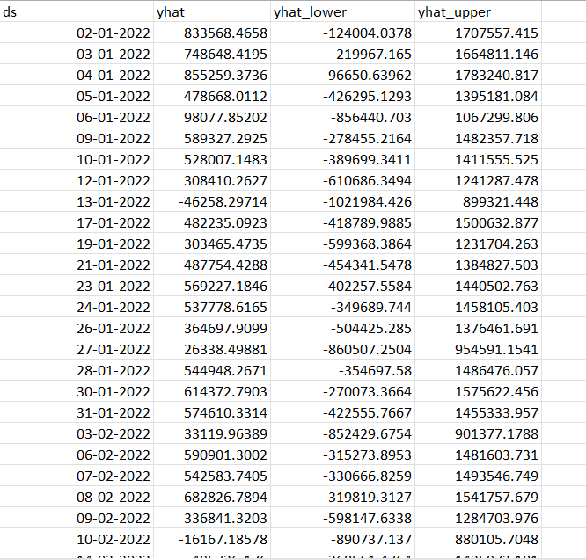
Fig: Forecast Results

- ds: The date stamp for each forecast point. Dates are not strictly consecutive (e.g., skips weekends or non-sales days), suggesting the model was trained on sporadic or event-based data, such as actual sales occurrences.
- yhat: The point forecast, or the model's predicted value for sales revenue on that date. These range from a minimum of approximately -46,258 (negative values indicate potential model limitations, as real sales can't be negative—possibly due to unconstrained extrapolation or noisy training data) to a maximum of about 2,110,351. The average yhat across all points is around 1,083,249.
- yhat_lower: The lower bound of the prediction interval (likely an 80% or 95% confidence interval, depending on model settings). This represents the pessimistic estimate, with values ranging from about -1,021,984 to 1,201,527 (average ~166,555). Wide negative lowers highlight high uncertainty in low-prediction scenarios.
- yhat_upper: The upper bound of the prediction interval, showing the optimistic estimate. These range from 880,105 to 3,037,550 (average ~2,001,212), again indicating significant variability and model uncertainty.
The wide intervals (often spanning over 1 million units) suggest the underlying sales data may have high volatility, seasonality, or limited historical samples, leading to less precise predictions. Units are likely in dollars ($), aligning with the dashboard's revenue metrics.

Overall Summary Statistics
Table 5.1: Summary of Forecast Results
Statistic | yhat | yhat_lower | yhat_upper
Count | 642 | 642 | 642
Mean | 1,083,249 | 166,555 | 2,001,212
Std Dev | 456,746 | 457,859 | 457,993
Min | -46,258 | -1,021,984 | 880,105
25% | 793,972 | -113,518 | 1,720,112
50% | 1,014,279 | 91,148 | 1,929,130
75% | 1,349,767 | 432,973 | 2,277,939
Max | 2,110,351 | 1,201,527 | 3,037,550

Trends and Insights
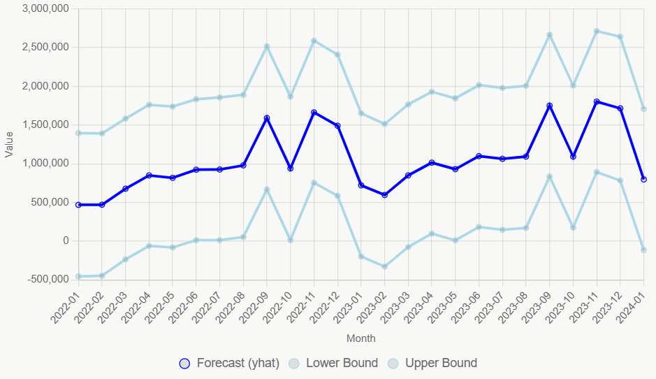
Fig: Trends and insights for Forcast Results

The forecasts show an overall upward trend in predicted sales from early 2022 (averaging ~400k–600k monthly) through mid-2023, peaking in late 2023 (e.g., November averages ~1.8M), before a noticeable decline into early 2024 (dropping back to ~800k monthly). This could reflect modeled seasonality, trends from the original dashboard data (which showed declining year-over-year sales), or external factors like market conditions. High uncertainty persists throughout, with some periods (e.g., mid-2022) showing tighter bounds and others (e.g., late 2023) wider due to potential outliers or sparse data.
For a visual overview, here's a line chart of the monthly aggregated averages (resampled for clarity, as the full 642 points would be too dense):
Grok can make mistakes. Always check original sources.
This output could be used for business planning, such as identifying potential revenue growth periods or risks in declining trends. If the model was trained on the dashboard's car sales data, it might incorporate factors like seasonality (e.g., higher sales in certain months) or trends (e.g., the observed yearly decline). For more accurate real-world use, consider retraining with updated data or adding constraints to avoid negative predictions.

CHAPTER VI - CONCLUSION
The sales performance dashboard reveals a car dealership (or chain) with total historical revenue around $7.1 million, dominated by SUVs, top models from BMW and Toyota, and strongest performance in regions like Austin. However, it highlights a clear declining trend in daily and yearly sales revenue through late 2023/early 2024, suggesting challenges such as market saturation, economic factors, or competition.
The forecast output (likely from a Prophet model) projects this data forward but shows an inconsistent pattern:
- Moderate daily revenues in 2022 (~$600k–$800k average),
- Growth to higher levels in 2023 (peaking with daily forecasts often exceeding $1.5–2 million in late months like November/December),
- Followed by a sharp drop in early 2024 (averaging ~$800k daily in January 2024).
This results in an overall modeled upward trend from 2022 to a 2023 peak, then a reversal—partially aligning with the dashboard's observed decline but projecting a temporary recovery before dropping again.

CHAPTER VII - FEATURE SCOPE AND APPENDIX

Feature Scope:
1. Sales Overview
- Total sales revenue
- Total profit and profit margin
- Number of orders and units sold
- Average order value (AOV)
- Sales growth comparison (MoM / YoY)

2. Time-Based Analysis
- Daily, weekly, monthly, quarterly, and yearly sales trends
- Seasonal sales pattern identification
- Peak and low sales period analysis

3. Product Performance Analysis
- Top-selling products
- Least-performing products
- Category-wise and subcategory-wise sales
- Product contribution to total revenue
- Stock vs sales performance

4. Regional / Location Analysis
- Sales by country, state, region, or city
- Region-wise revenue and profit comparison
- High-performing and low-performing markets

5. Customer Analysis
- New vs returning customers
- Customer segmentation based on purchase behavior
- Customer lifetime value (CLV)
- Average purchase frequency
- High-value customer identification

6. Sales Representative Performance
- Individual sales rep performance
- Target vs achieved comparison
- Commission and incentive tracking
- Ranking of sales representatives

7. Channel Performance
- Sales by channels (Online, Retail, Distributor, Partner)
- Channel-wise revenue contribution
- Conversion rates per channel

- Target & KPI Tracking
- Sales target achievement percentage
- KPI monitoring (revenue, profit, conversion rate)
- Performance alerts for underachieved targets

9. Forecasting & Predictive Insights
- Future sales prediction using historical data
- Demand forecasting
- Trend-based recommendations

10. Filters & Interactivity
- Dynamic filters (date, product, region, sales rep)
- Drill-down and drill-through analysis
- Interactive charts and slicers

11. Data Visualization
- Bar, line, pie, donut, and area charts
- Heat maps and geographical maps
- KPI cards and scorecards

12. Reporting & Export
- Download reports (PDF, Excel)
- Scheduled report generation
- Shareable dashboard links

13. Data Security & Access Control
- Role-based access (Admin, Manager, Sales Rep)
- Data privacy and protection
- Secure login authentication

14. Integration & Data Sources
- Integration with CRM systems
- ERP and POS system connectivity
- Real-time or scheduled data refresh

15. Performance Optimization
- Fast data loading and query optimization
- Scalable architecture for large datasets

Appendix :
import pandas as pd
import matplotlib.pyplot as plt
from neuralprophet import NeuralProphet

# -------------------- Load and Clean Data --------------------
dataset = pd.read_csv(r"C:\Users\GANGOTRI\OneDrive\Desktop\Sales Performance Dashboard\car sales.csv")
dataset.columns = dataset.columns.str.strip()
dataset.rename(columns={'Price ($)': 'Price'}, inplace=True)
dataset['Date'] = pd.to_datetime(dataset['Date'], errors='coerce')
dataset.dropna(subset=['Date', 'Price'], inplace=True)

# -------------------- Prepare Daily Sales Data --------------------
daily_sales = dataset.groupby('Date')['Price'].sum().reset_index()
daily_sales.columns = ['ds', 'y']
daily_sales = daily_sales.sort_values('ds')

# -------------------- Train NeuralProphet Model --------------------
model = NeuralProphet(
n_lags=30,
n_forecasts=30,
yearly_seasonality=True,
weekly_seasonality=True
)
metrics = model.fit(daily_sales, freq='D')

# -------------------- Forecast Next 30 Days --------------------
future = model.make_future_dataframe(daily_sales, periods=30)
forecast = model.predict(future)

# -------------------- Print Available Columns --------------------
print("\nAvailable Forecast Columns:\n")
print(forecast.columns)

# -------------------- Extract Forecast Output --------------------
forecast_output = forecast[['ds', 'yhat1']].tail(30)

# -------------------- Print Forecast Output --------------------
print("\n================= FORECAST OUTPUT (NEXT 30 DAYS) =================\n")
print(forecast_output)

# -------------------- Save Forecast Output CSV --------------------
forecast_output.to_csv(
r"C:\Users\GANGOTRI\OneDrive\Desktop\Sales Performance Dashboard\forecastoutput.csv",
index=False
)

print("\n✅ Forecast Output saved successfully as forecastoutput.csv")

# -------------------- Save Full Forecast CSV --------------------
forecast.to_csv(
r"C:\Users\GANGOTRI\OneDrive\Desktop\Sales Performance Dashboard\full_forecast.csv",
index=False
)
print("✅ Full Forecast saved successfully as full_forecast.csv")

# -------------------- Plot Forecast --------------------
fig = model.plot(forecast)
plt.show()

###############ALL DIFFERENT KINDS OF Models#############################################################ARIMA

# from statsmodels.tsa.arima.model import ARIMA
# from sklearn.metrics import mean_absolute_error
# import pandas as pd

# # Load and prepare data
# df = pd.read_csv("car sales.csv")
# df['Date'] = pd.to_datetime(df['Date'], dayfirst=True)
# daily_sales = df.groupby('Date')['Price ($)'].sum().reset_index()
# ts = daily_sales.set_index('Date')['Price ($)']

# # Split train/test
# train = ts[:-30]
# test = ts[-30:]

# # Fit ARIMA model (e.g., ARIMA(5,1,0))
# model = ARIMA(train, order=(5, 1, 0))
# fitted = model.fit()

# # Forecast
# forecast = fitted.forecast(steps=30)

# # Compare with test
# mae = mean_absolute_error(test, forecast)
# print(f"ARIMA MAE: {mae}")

##################w##################################################Prophet

# import pandas as pd
# from prophet import Prophet
# from sklearn.metrics import mean_absolute_error

# # ✅ Correct file path - MUST be a CSV file, not .py
# df = pd.read_csv(r"C:\Users\surap\Desktop\Sales Performance Dashboard\car sales.csv", on_bad_lines='skip')

# # Convert Date column
# df['Date'] = pd.to_datetime(df['Date'], dayfirst=True)

# # Aggregate daily total sales
# daily_sales = df.groupby('Date')['Price ($)'].sum().reset_index()
# daily_sales.columns = ['ds', 'y']

# # Train-test split
# train = daily_sales.iloc[:-30]
# test = daily_sales.iloc[-30:]
# # Prophet model
# model = Prophet(daily_seasonality=True)
# model.fit(train)

# # Predict
# future = model.make_future_dataframe(periods=30)
# forecast = model.predict(future)

# comparison_df = test.merge(forecast[['ds', 'yhat']], on='ds', how='left')
# comparison_df.dropna(subset=['yhat'], inplace=True)
# mae = mean_absolute_error(comparison_df['y'], comparison_df['yhat'])

# print(f"Prophet MAE: {mae}")

###################################################XGBOOST
# import pandas as pd
# import xgboost as xgb
# from sklearn.metrics import mean_absolute_error
# from sklearn.model_selection import train_test_split

# # Load data
# df = pd.read_csv(r"C:\Users\surap\Desktop\Sales Performance Dashboard\car sales.csv")
# df['Date'] = pd.to_datetime(df['Date'], dayfirst=True)

# # Aggregate by date
# daily_sales = df.groupby('Date')['Price ($)'].sum().reset_index()
# daily_sales.columns = ['ds', 'y']

# # Create date features
# daily_sales['day'] = daily_sales['ds'].dt.day
# daily_sales['month'] = daily_sales['ds'].dt.month
# daily_sales['year'] = daily_sales['ds'].dt.year
# daily_sales['dayofweek'] = daily_sales['ds'].dt.dayofweek

# X = daily_sales[['day', 'month', 'year', 'dayofweek']]
# y = daily_sales['y']

# # Split
# X_train, X_test, y_train, y_test = train_test_split(X, y, test_size=30, shuffle=False)

# # Model
# model = xgb.XGBRegressor()
# model.fit(X_train, y_train)

# # Predict and evaluate
# y_pred = model.predict(X_test)
# mae = mean_absolute_error(y_test, y_pred)
# print(f"XGBoost MAE: {mae}")

#####################################################LSTM
# import pandas as pd
# import numpy as np
# from sklearn.preprocessing import MinMaxScaler
# from sklearn.metrics import mean_absolute_error
# from tensorflow.keras.models import Sequential
# from tensorflow.keras.layers import LSTM, Dense

# # Load and aggregate data
# df = pd.read_csv(r"C:\Users\surap\Desktop\Sales Performance Dashboard\car sales.csv")
# df['Date'] = pd.to_datetime(df['Date'], dayfirst=True)
# daily_sales = df.groupby('Date')['Price ($)'].sum().reset_index()
# daily_sales.columns = ['ds', 'y']

# # Scale values
# scaler = MinMaxScaler()
# scaled_y = scaler.fit_transform(daily_sales[['y']])

# # Create sequences
# X, y = [], []
# for i in range(10, len(scaled_y)):
# X.append(scaled_y[i-10:i, 0])
# y.append(scaled_y[i, 0])

# X, y = np.array(X), np.array(y)
# X = X.reshape((X.shape[0], X.shape[1], 1))

# # Train/test split
# split = len(X) - 30
# X_train, X_test = X[:split], X[split:]
# y_train, y_test = y[:split], y[split:]

# # Model
# model = Sequential()
# model.add(LSTM(50, return_sequences=False, input_shape=(X_train.shape[1], 1)))
# model.add(Dense(1))
# model.compile(optimizer='adam', loss='mse')
# model.fit(X_train, y_train, epochs=50, verbose=0)

# # Predict and inverse scale
# pred = model.predict(X_test)
# y_pred = scaler.inverse_transform(pred)
# y_test_actual = scaler.inverse_transform(y_test.reshape(-1, 1))

# mae = mean_absolute_error(y_test_actual, y_pred)
# print(f"LSTM MAE: {mae}")
#################################FACEBOOK NEURAL PROPHET
# Install first: pip install neuralprophet
# from neuralprophet import NeuralProphet
# import pandas as pd
# from sklearn.metrics import mean_absolute_error

# # Load data
# df = pd.read_csv(r"C:\Users\surap\Desktop\Sales Performance Dashboard\car sales.csv")

# # Parse dates with automatic inference, handle errors by coercing to NaT
# df['Date'] = pd.to_datetime(df['Date'], dayfirst=False, errors='coerce')

# # Check for any unparseable dates and drop them
# if df['Date'].isna().any():
# print("Warning: Some dates could not be parsed and will be dropped:")
# print(df[df['Date'].isna()])
# df = df.dropna(subset=['Date'])

# # Aggregate sales per day
# daily_sales = df.groupby('Date')['Price ($)'].sum().reset_index()
# daily_sales.columns = ['ds', 'y']

# # Sort by date to avoid issues
# daily_sales = daily_sales.sort_values('ds')

# # Train/test split - last 30 days as test
# train = daily_sales.iloc[:-30]
# test = daily_sales.iloc[-30:]

# # Initialize and train NeuralProphet
# model = NeuralProphet()
# model.fit(train, freq='D')

# # Create future dataframe and forecast for 30 days
# future = model.make_future_dataframe(train, periods=30)
# forecast = model.predict(future)

# # Prepare for comparison - join on date
# forecast_subset = forecast[['ds', 'yhat1']]
# comparison = test.merge(forecast_subset, on='ds', how='left').dropna()

# # Calculate Mean Absolute Error
# mae = mean_absolute_error(comparison['y'], comparison['yhat1'])
# print(f"NeuralProphet MAE: {mae}")

# Import necessary libraries
import pandas as pd
import matplotlib.pyplot as plt
from neuralprophet import NeuralProphet

# Load and clean data
dataset = pd.read_csv(r"C:\Users\surap\Desktop\Sales Performance Dashboard\car sales.csv")
dataset.columns = dataset.columns.str.strip()
dataset.rename(columns={'Price ($)': 'Price'}, inplace=True)
dataset['Date'] = pd.to_datetime(dataset['Date'], errors='coerce')
dataset.dropna(subset=['Date', 'Price'], inplace=True)

# Prepare time series
daily_sales = dataset.groupby('Date')['Price'].sum().reset_index()
daily_sales.columns = ['ds', 'y']
daily_sales = daily_sales.sort_values('ds')

# Initialize and fit model
model = NeuralProphet(
n_lags=30,
n_forecasts=30,
yearly_seasonality=True,
weekly_seasonality=True
)
metrics = model.fit(daily_sales, freq='D')

# Make forecast
future = model.make_future_dataframe(daily_sales, periods=30)
forecast = model.predict(future)

# Save results
forecast[['ds', 'yhat1']].tail(30).to_csv(
r"C:\Users\surap\Desktop\Sales Performance Dashboard\forecast_results.csv",
index=False
)

# Plot results
fig = model.plot(forecast)
plt.show()

CHAPTER VIII - REFERENCES
[1] Ackermann, N. (2018). Introduction to 1D convolutional neural networks in Keras for time sequences. Medium. Available at: https://blog.goodaudience.com/introduction-to-1d-convolutional-neural-networks-in-keras-for-time-sequences-3a7ff801a2cf (Accessed: 23 November 2021).

[2] Alon, I., Qi, M., & Sadowski, R. J. (2001). Forecasting aggregate retail sales: A comparison of Artificial Neural Networks and traditional methods. Journal of Retailing and Consumer Services, 8(3), 147–156.

[3] Alpaydin, E. (2009). Introduction to Machine Learning. MIT Press.

[4] Arnoux, P. H., Xu, A., Boyette, N., Mahmud, J., Akkiraju, R., & Sinha, V. (2017). 25 tweets to know you: A new model to predict personality with social media. Proceedings of the International AAAI Conference on Web and Social Media, 11.

[5]Avuçlu, E., & Elen, A. (2020). Evaluation of train and test performance of machine learning algorithms and Parkinson diagnosis with statistical measurements. Medical & Biological Engineering & Computing, 58(11), 2775–2788.

[6] Box, G. E. P., & Jenkins, G. M. (1970). Control. San Francisco: Holden-Day.

[7] Brockwell, P. J., Davis, R. A., & Calder, M. V. (2002). Introduction to Time Series and Forecasting (2nd ed.). New York: Springer.

[8] Brownlee, J. (2016). How to backtest machine learning models for time series forecasting. Machine Learning Mastery. Available at: https://machinelearningmastery.com/backtest-machine-learning-models-time-series-forecasting/ (Accessed: 23 November 2021).

[9] Brownlee, J. (2017a). How to grid search ARIMA model hyperparameters with Python. Machine Learning Mastery. Available at: https://machinelearningmastery.com/grid-search-arima-hyperparameters-with-python/ (Accessed: 23 November 2021).

[10] Brownlee, J. (2017b). Time series forecasting with the long short-term memory network in Python. Machine Learning Mastery. Available at: https://machinelearningmastery.com/time-series-forecasting-long-short-term-memory-network-python/ (Accessed: 23 November 2021).

[11]Brownlee, J. (2018a). How to develop LSTM models for time series forecasting. Machine Learning Mastery. Available at: https://machinelearningmastery.com/how-to-develop-lstm-models-for-time-series-forecasting/ (Accessed: 23 November 2021).

[12] Brownlee, J. (2018b). A gentle introduction to exponential smoothing for time series forecasting in Python. Machine Learning Mastery. Available at: https://machinelearningmastery.com/exponential-smoothing-for-time-series-forecasting-in-python/ (Accessed: 23 November 2021).

[13] Chakraborty, A., & Kar, A. K. (2017). Swarm intelligence: A review of algorithms. In: Nature-Inspired Computing and Optimization, pp. 475–494.

[14] Choi, B. (2012). ARMA Model Identification. Springer Science & Business Media.

[15] Chopra, S., & Meindl, P. (2016). Supply Chain Management: Strategy, Planning, and Operation.

[16] Tableau Community (n.d.). Tableau Community Documentation. Available at: https://community.tableau.com/docs/DOC-1236 (Accessed: 23 November 2021).

